CI and CD : Continues Integration and Continues Delivery or deployment

Remote Repository

Dev1 Dev2 Dev3 Dev4

Code changes made by individual team members are merged together into working application or software. This phase is known as Integration phase.

Integration phase is hard work which often result in code conflicts.

Jenkin : Jenkin is open source automation tools (CI and CD tool) written using Java. It is plugin base tool so base upon our requirement we can add third party plugin to run the application.

Jenkin is use to build the project (compile, run, test, create jar or war files). It also allow to use continuous delivery or deployment our software by integrating with a large number of testing and deployment technologies.

Jenkin will allow to connect with sub version tool like github or any other remote repository to build the project.

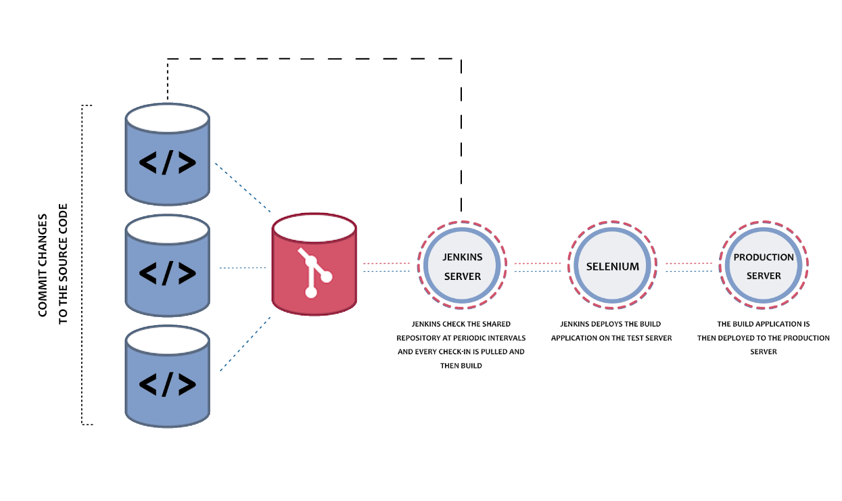

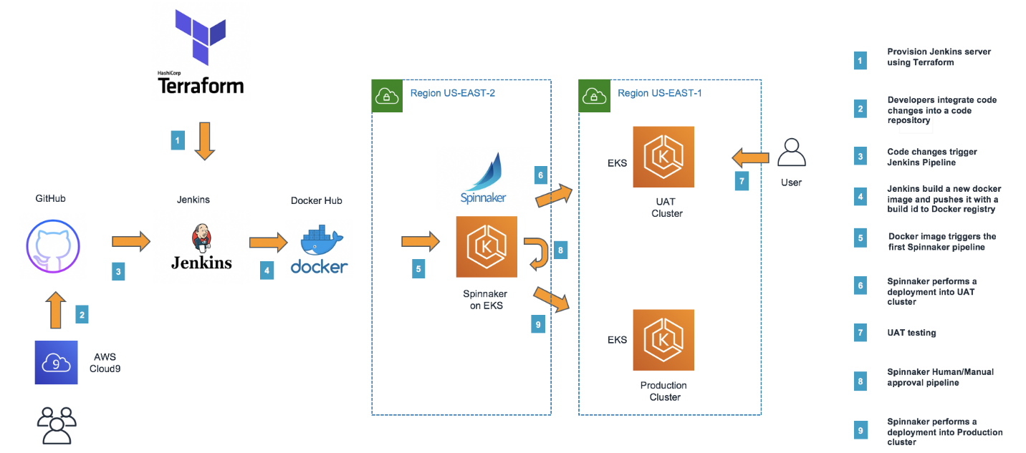

We can run the Jenkin software 3 ways

1. Exe software installed.
2. Running war file using Jenkin command

Download war file and paste in C:\Program Files\apache-tomcat-9.0.63\webapps tomcat folder.

java –jar jenkin.war

after run successfully we have to open command prompt with url as

<http://localhost:8080>

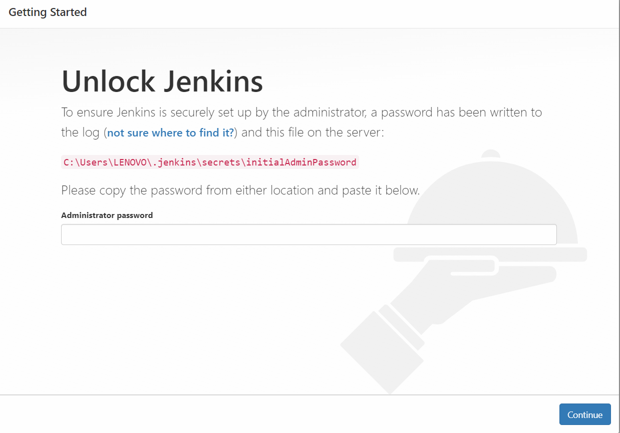

It will ask the password and random password present in command prompt.

